|  |
| --- |
|  |
| Business Plan  Team 8 Student Ids:  23087843  23089900  23076113  23051102  *Sight-Savvy* |
| |  |  |  | | --- | --- | --- | |  | Word count: 3609 | [Course title] | |

|  |  |  |
| --- | --- | --- |
| Sr. No. | Context | Pg. No. |
| 1 | Executive Summary | 2 |
| 2 | Introduction | 2 |
| 3 | Market Analysis | 3 |
| 4 | Operational Strategy and Timeline | 5 |
| 5 | Marketing | 7 |
| 6 | Sales Strategy | 8 |
| 7 | Financial Plan | 9 |
| 8 | IPO Planning and Execution | 11 |
| 9 | Conclusion | 12 |
| 10 | References | 13 |
| 11 | Appendix | 14 |

***Executive Summary***

"The best way to predict the future is to invent it." - Alan Kay

At the forefront of the eyewear industry, Sight Savvy is pioneering a future where glasses are not just vision-correcting tools but essential, stylish lifestyle accessories. Through the integration of advanced technology with elegant design, Sight Savvy offers a personalized shopping experience powered by our proprietary 3D facial scanning technology and AI-driven recommendations. Operating from Cardiff, we take full advantage of local educational and logistical strengths to serve a diverse UK market. Our approach emphasizes sustainability in production and logistics, driving efficiency and reducing our environmental footprint. Over five years, Sight Savvy has not only reshaped its sector but has also laid a solid financial groundwork for future growth, including an anticipated IPO.

***Introduction***

In today's world, technology enhances every aspect of our lives, so why should eyewear be any different? At our company, we envision a future where glasses do more than correct vision—they enhance your daily lifestyle through innovative technology, style, and comfort. This vision redefines traditional eyewear, transforming glasses from mere visual aids into essential, stylish lifestyle accessories. As we forge ahead, we are not just creating eyewear; we are crafting new ways to interact with the world. Join us on this visionary journey, where every pair of glasses is a step toward a clearer and more vibrant life.

It is projected that the global market for eyewear would have a healthy yearly growth rate over the course of the subsequent five years. It is important to note that crucial accelerators for expansion include technological developments, altering consumer megatrends, and transformations in market structure. Because the requirement for vision correction increases and becomes more complicated with age, ageing is a particularly major global demographic phenomenon that influences eye care. This is because of the fact that the demand for vision correction increases with age. Furthermore, a rise in the amount of time spent in front of a screen, particularly among children, may result in more severe consequences than was previously anticipated, which further emphasises the ongoing requirement for preventative eye care.

Sight Savvy was established with the goal of providing trendy eyewear of superior quality to consumers of all socioeconomic backgrounds. The business is in a position to satisfy the specific requirements of its varied clients since it makes use of the abundant educational resources and logistical advantages that Cardiff has to offer. This report provides an overview of the business strategy that will be implemented over the next five years, including a comprehensive plan for operations, an analysis of the market, financial planning, and expected outcomes.

***Market Analysis***

***Industry Overview***

Our company's core competency is delivering superior optical products and associated services to customers located in the United Kingdom. These products have the potential to appeal to a diverse range of consumers. They consist of individuals of all colours, ethnicities, ages, and genders who need eyewear such as contact lenses, sunglasses, and glasses. The principal geographic emphasis would be on the populace of the city housing the initial stores, with potential expansion to encompass the entirety of the United Kingdom when online sales become available. The manufacturing and design processes ensure that the products are accessible to a diverse population encompassing various socioeconomic classes and income brackets. Additionally, our customers' concerns regarding budget are addressed by the customisations we provide.

***Target Market***

“Global eyewear market revenue is anticipated to reach £114.20 billion in 2024. It is anticipated to expand at a 1.71 percent CAGR between 2024 and 2028. Spectacle Lenses constitute the most substantial market segment, boasting a market volume of £47.46 billion in 2024. In contrast to global trends, the United States is anticipated to generate the maximum revenue in this market in 2024, amounting to £27,040 million.

The global eyewear market is anticipated to generate an average revenue of £14.74 per individual in 2024. The market is anticipated to reach 10.8 billion units by 2028. Furthermore, volume growth of 2.4% is anticipated for the market in 2025. By 2024, the average volume per individual in the eyewear market is anticipated to reach 1.3 units. An approximate 85 percent of eyewear market sales in 2024 will be categorised as non-luxury. There is a growing global demand for fashionable and environmentally sustainable eyewear in numerous nations.” (Eyewear - Worldwide | Statista Market Forecast, n.d.).

***Competitive Analysis***

Sight Savvy started operating by conducting an exhaustive market and competitor analysis. It has consistently been our top priority to maintain the uniqueness of Sight Savvy. Boots Optician, Specsaver, and Vision Express are our main rivals. There are numerous distinguishing characteristics that set Sight Savy apart from its rivals. A diverse selection of customisations is available from us, that includes frames, materials, colours, and patterns. Our sole substantial offering is a clip-on eyeglasses frame, which is an additional distinctive feature that is not easily accessible in the market. Our highly adaptable clip-on spectacles are certain to please our customers. Our primary objective with this organisation is to establish an exceptionally convenient buying environment. As a result, we have introduced home eye testing with frame try-ons as a luxury. This home testing service is for everyone, not just those who are unable to place an order online or visit the store.

This service will save time for our customers. Our website now features an advanced virtual try-on service, enhanced with the latest in artificial intelligence and augmented reality technology. This innovative tool automatically suggests the best frames for you by analysing your face shape, ensuring a personalized and convenient shopping experience. Through reducing the amount of ambiguity associated with purchasing eyewear online, this 3D facial recognition technology will improve the customer experience through the provision of personalised recommendations and virtual try-on opportunities.

Additionally, it will be beneficial in instances of product out-of-stock situations and customisation, allowing consumers to select desired designs and colours based on their personal preferences. Our products distinguish themselves not only by offering competitive and remarkable services, but also by virtue of their exceptional comfort and style. All of these characteristics distinguish Sight Savvy from its competitors.

***Operational Strategy and Timeline***

***Production Techniques***

At Sight Savvy, we have developed a state-of-the-art production process that prioritizes both customization and rigorous quality control. This process involves the integration of advanced manufacturing technologies with time-honoured craftsmanship techniques to produce eyewear that not only meets but exceeds industry standards. Our production facilities are equipped with the latest machinery that enhances our capability to offer a wide range of customizable options in eyewear, allowing customers to select from various frame materials, designs, and finishes. Every frame undergoes a meticulous inspection process at multiple stages of production. This ensures each product adheres to our strict quality criteria, which cover everything from material integrity to the precision of lens fitting. This detailed attention to quality is fundamental to creating products that are both aesthetically pleasing and durable, providing our customers with eyewear that is as reliable as it is stylish.

***Technological Infrastructure***

The technological foundation of Sight Savvy is anchored in our cutting-edge software solutions, which feature advanced capabilities like 3D facial scanning and AI-driven frame recommendation systems. This sophisticated software tailors the shopping experience by suggesting eyewear frames that perfectly match each customer's unique facial features and personal style. Our AI algorithms are trained on an extensive dataset of facial attributes and frame designs, making them highly adept at offering accurate and visually appealing recommendations. This not only streamlines the frame selection process but also enhances customer satisfaction by ensuring a quick, efficient, and personalized shopping experience. The integration of these technologies into our operations has set a new standard in the eyewear industry, positioning Sight Savvy at the forefront of technological innovation in personalized eyewear.

***Logistics and Supply Chain Management***

Sight Savvy's logistics strategy is meticulously designed to optimize both efficiency and sustainability throughout our production and delivery processes. We have streamlined our supply chain to minimize waste and shorten transit times, working in close partnership with suppliers who share our commitment to sustainability. These partnerships focus on the use of eco-friendly materials and practices, ensuring that our operations not only deliver high-quality products but also protect the environment. Our supply chain is tightly managed to ensure that all products are delivered on schedule and in impeccable condition, thereby enhancing customer satisfaction and maintaining high standards of quality. Moreover, our logistics operations leverage real-time data analytics to remain agile and responsive to both market trends and operational challenges. This ongoing optimization helps us maintain a competitive edge, ensuring that Sight Savvy can quickly adapt to changes and continue to deliver exceptional service and products to our customers.

***Development Timeline***

*Year 1: Launch and Market Entry*

During its inaugural year, Sight Savvy focused on establishing a strong brand identity and a loyal customer base. The "first frame free" promotion effectively attracted initial customers, allowing the company to absorb the cost through subsequent sales of lenses and frame upgrades. Strategic partnerships with local universities helped tap into the vibrant student market, providing a steady stream of youthful customers intrigued by both style and technology. The company also launched a user-friendly online platform, which was pivotal in ensuring easy access to its products and services, thereby laying the foundation for a scalable business model.

*Year 2: Service Expansion*

The second year was characterized by a significant expansion in services, particularly with the launch of a home eye check-up service. This service was designed to cater to customers who value convenience, such as busy professionals and elderly clients. The introduction of a nominal upfront fee for home visits, deductible from the final purchase, further streamlined the customer experience, making the service appealing and hassle-free. This expansion not only solidified customer loyalty but also expanded the company's market reach into metropolitan areas without the need for physical stores.

*Year 3: Product Line Expansion*

In third year, we diversified its product offerings by introducing a range of polarized sunglasses and additional line of eyewear accessories which focuses on the Gen-Z segment and vintage look. The new products were developed in response to customer feedback and market research, which indicated a growing demand for specialized eyewear that caters to outdoor activities and fashion trends. The launch of these new lines helped the company to attract a broader customer base, including sports enthusiasts and fashion-conscious consumers, thereby enhancing its market share and brand visibility.

*Year 4: Technological Advancements*

The focus of the fourth year (i.e., the current year) was on advancing the technological aspects of the business. The upgraded mobile app now included enhanced 3D scanning capabilities and AI tools that not only recommended frames based on facial analysis but also suggested styles based on lifestyle preferences. Additionally, the company introduced a line of durable, child-friendly frames made from innovative materials that can withstand rough handling. These advancements significantly enhanced the online shopping experience and positioned Visionary Eyewear as a leader in technological innovation within the eyewear industry.

*Year 5: Innovation and Franchising*

Looking ahead to the fifth year, Sight Savvy plans to further its innovation and begin scaling the business through franchising. The company intends to invest in advanced 3D printing technologies to enable on-demand customization of frames, significantly reducing production times and costs. Furthermore, it plans to explore groundbreaking lens technologies that could potentially reverse the effects of myopia in children, in collaboration with optical health experts. By developing a robust franchising model, we are aiming to expand retail footprint nationally, providing comprehensive training and support systems to franchisees, thereby facilitating a successful national expansion.

***Marketing***

At Sight Savvy, we position ourselves as leaders in tech-driven eyewear solutions. Our commitment is to blend the latest technology with style and comfort, making each pair of glasses not just a tool for better vision but an integral part of lifestyle enhancement. This strategic positioning allows us to stand out in a crowded marketplace as we leverage cutting-edge technology to deliver superior products and services.

***Promotional Strategies***

Over the past four years, we have successfully executed a variety of marketing initiatives designed to establish our brand and attract a diverse customer base. As we approach our fifth year, our focus will shift towards consolidating our gains and introducing innovative campaigns that reflect our technological advancements.

Digital Campaigns: We will continue to invest in targeted online advertising campaigns, making use of sophisticated data analytics to refine our ad placements on platforms like Google and Facebook, ensuring maximum visibility among our target demographics.

Print and Outdoor Advertising: In addition to maintaining a strong online presence, we plan to expand our reach through strategic placements in top fashion and lifestyle magazines, alongside outdoor advertising in high-traffic areas. These efforts are not just about sales but about building a global brand presence.

Engagement through Content: We will enhance our engagement by collaborating with influencers and media outlets to showcase our innovative products, emphasizing our unique selling propositions like virtual try-on technology and customizable options.

***Customer Engagement***

Our engagement strategy focuses on building long-term relationships through exceptional service and interactive online experiences.

Social media: We plan to ramp up our social media efforts to foster community engagement, share useful content, and respond to customer inquiries and feedback in real-time.

Website Features: Our website will feature interactive elements such as AR-based virtual try-on capabilities, allowing customers to see themselves in various eyewear options from the comfort of their homes.

Customer Service Excellence: We are committed to providing unparalleled customer service, with a focus on speedy responses and personalized support, ensuring every interaction with our brand is positive and memorable.

***Sales Strategy***

Our sales model is multifaceted, combining direct-to-consumer online sales with physical retail experiences and B2B partnerships.

Online Platform: Our website serves as the primary sales channel, offering a full range of products and exclusive online promotions.

Pop-Up Stores: We utilize pop-up stores in high-traffic urban areas to reach potential customers, allowing them to experience our products firsthand and receive on-the-spot consultations.

B2B Partnerships: Strategic alliances with fashion retailers and corporate clients will enable us to expand our reach and embed our products in various consumer touchpoints.

***Pricing Strategy***

Our unique selling proposition hinges on customization and technology. We offer premium products that are competitively priced, reflecting the high value of innovative features such as adjustable tints, flexible frames, and digital compatibility with various devices. This justifies our premium pricing while ensuring customer satisfaction with the value received.

***Sales Forecasts***

Based on our comprehensive market analysis and the effectiveness of our marketing strategies, we project a steady growth in sales. We anticipate a significant boost in our customer base and an increase in unit sales, driven by our expanded product offerings and enhanced marketing efforts. Specific figures include an expected increase in sales volume in the fifth year, reflecting both the expansion of our product lines and deeper market penetration.

***Financial Plan***

***Note:*** *For a detailed breakdown of the financial analysis and supporting calculations, please refer to the Appendix at the end of this report.*

Sight Savvy has demonstrated significant growth in financial performance over the past five years, underpinned by strong profitability metrics, effective liquidity management, and a stable cash flow framework. Our Return on Assets (ROA) has impressively increased from a mere 0.0274% in Year 1 to 5.01% in Year 5, illustrating a consistent improvement in utilizing assets to generate profits. Similarly, the Return on Equity (ROE) peaked at 58.75% in Year 4, reflecting substantial returns on shareholder investments and indicating effective leverage and profitability strategies. Our Gross Profit Margin has also shown remarkable stability, ranging from 33% to 41% over the years, underscoring our ability to maintain profitability even amidst fluctuating market conditions.

In terms of liquidity, Sight Savvy has maintained robust ratios, with the Current Ratio starting strong at 2.51 in Year 1 and adjusting to a healthy 1.31 by Year 5. This suggests prudent management of liquid assets to cover short-term liabilities. The Quick Ratio has also improved, reaching 1.27 by Year 5, which supports our capacity to meet immediate financial obligations without depending on inventory liquidation. Our cash flow activities have consistently reinforced our operational and investment initiatives, with net cash flows providing the necessary stability for ongoing operations and facilitating strategic capital expenditures to foster growth. This has been critical in maintaining our financial health and supporting expansive strategies.

Financial stability has been further demonstrated through our Equity Ratio, which has evolved from a high of 0.82 in Year 1 to a more diversified structure of 0.39 by Year 5. This transition reflects our strategic financial management, utilizing various financing options to fuel expansion without compromising our equity base.

From our Balance Sheet and Income Statement, there are several highlights: total assets grew significantly from £71,968 in Year 1 to £11,549,066 in Year 5, mirroring our aggressive reinvestment and capability acquisition strategies. Liabilities have been strategically managed to support this expansion while maintaining a solid equity base. Meanwhile, revenues have surged from £497,500 in Year 1 to £258,650,000 in Year 5, showcasing our aggressive market penetration and expansion efforts. Net income has also seen a remarkable increase from £1,977 in Year 1 to £57,959,108 in Year 5, highlighting our successful growth strategies and adaptability in the market. (Note: For the references of all these numbers please have a look in Appendix).

Our break-even analysis shows that the required sales volume to cover costs has significantly increased, reflecting our strategic shift towards larger markets and more extensive product lines. This marks a key aspect of our growth strategy, aiming to scale operations to meet rising market demands efficiently.

Overall, Sight Savvy's financial trajectory over these five years has laid a solid foundation for continued success and expansion, positioning us well for future challenges and opportunities in the dynamic eyewear industry.

***IPO Planning and Execution***

Sight Savvy's IPO planning and execution are meticulously structured with a clear timeline set for Year 5. Key milestones have been established to ensure a seamless transition to public trading. In Year 3, we plan to complete all necessary financial auditing and commence the formal market valuation process. This step will help us establish a grounded evaluation of our worth in the public domain. By Year 4, we aim to engage with potential underwriters to begin the detailed preparations for our IPO. This phase is crucial as it sets the groundwork for our public offering, ensuring that all legal and financial frameworks are robust and IPO-ready. Finally, in Year 5, we plan to launch the IPO, following all necessary regulatory approvals and strategic market positioning.

The benefits of going public for Sight Savvy are substantial. Firstly, achieving public trading status will significantly elevate our market trustworthiness, enhancing our credibility among investors and customers alike. Furthermore, listing on the stock market will boost our brand visibility exponentially, reaching a wider audience and solidifying our market presence. The capital raised through the IPO will be strategically reinvested into next-generation product development, international market expansion, and scaling our operations, fuelling our growth and innovation trajectory.

However, embarking on an IPO also presents certain risks that we are preparing to mitigate. Market volatility is an inherent risk associated with public markets. To safeguard against this, we are setting up a reserve fund and adopting conservative growth projections to maintain financial stability during market downturns. We are also proactively engaging with regulatory bodies to ensure all compliance measures are met well before our IPO, thereby smoothing our transition to public status. Additionally, to manage the increase in operational demand that typically follows an IPO, we are strengthening our supply chain logistics and enhancing our customer service capabilities to support and sustain this growth. By addressing these risks head-on, Sight Savvy is positioning itself to not only manage the challenges of going public but to thrive in the new environment.

***Conclusion***

Sight Savvy has successfully established itself as a trailblazer in the tech-driven eyewear market, achieving this status through relentless innovation and an unwavering commitment to customer-centric solutions. Our approach has not only involved adapting swiftly to the evolving market trends but also pre-emptively addressing future consumer needs, thus allowing us to consistently stay ahead of market demands and exceed consumer expectations. This strategic foresight, coupled with our ongoing enhancements in technological capabilities from advanced AI-driven frame selection to our pioneering 3D facial scanning technology

has solidified our reputation as industry leaders.

As we prepare for an initial public offering, we find ourselves in a strong position to capitalize on our past achievements for sustained growth and continued innovation. This pivotal move toward becoming a publicly traded entity is set to significantly boost our market visibility and attract further investment, which will support our ambitious plans for scaling our operations and enhancing our product offerings. Our commitment remains firm on blending style, comfort, and cutting-edge technology in eyewear, ensuring that every pair of glasses we produce is not just a tool for better vision but a crucial part of an enhanced lifestyle.

As we look to the future, we are inspired by the notion that "Vision is the art of seeing what is invisible to others" - Jonathan Swift. This guiding principle challenges us to continually look beyond the conventional, to innovate and envision the myriad possibilities that lie ahead. It is this philosophy that will continue to drive our endeavors, encouraging us to explore new horizons and unveil groundbreaking opportunities in a dynamic and ever-changing marketplace. In doing so, we aim to redefine not only the eyewear industry but also how vision is perceived and experienced around the world.

***References***

*Eyewear - Worldwide | Statista Market Forecast*. (n.d.). Statista. <https://www.statista.com/outlook/cmo/eyewear/worldwide?currency=GBP>

***Appendix***

***Balance Sheet***

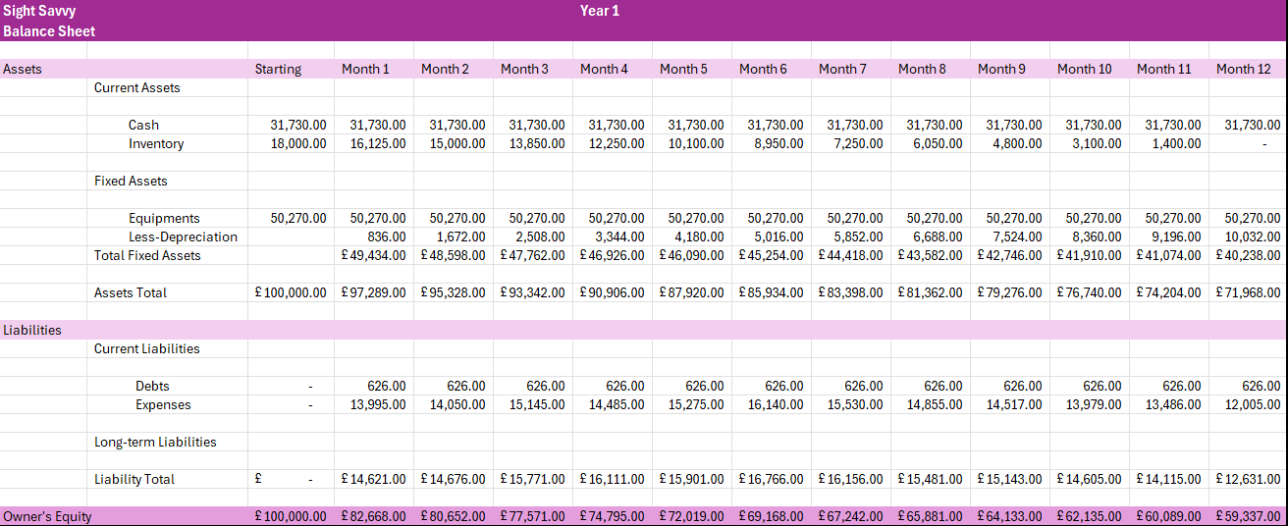

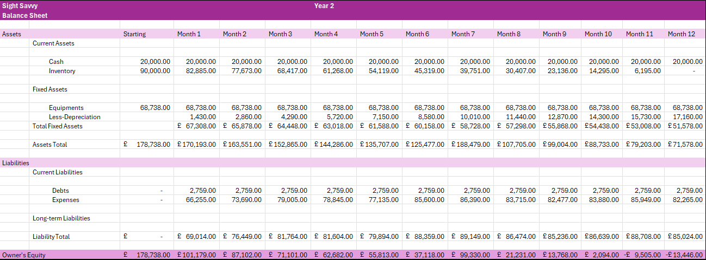

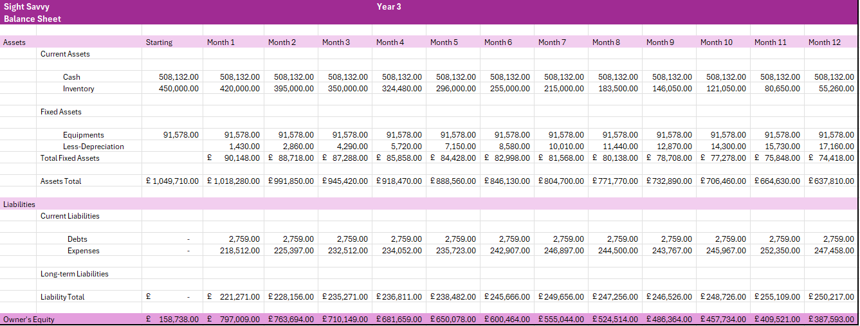

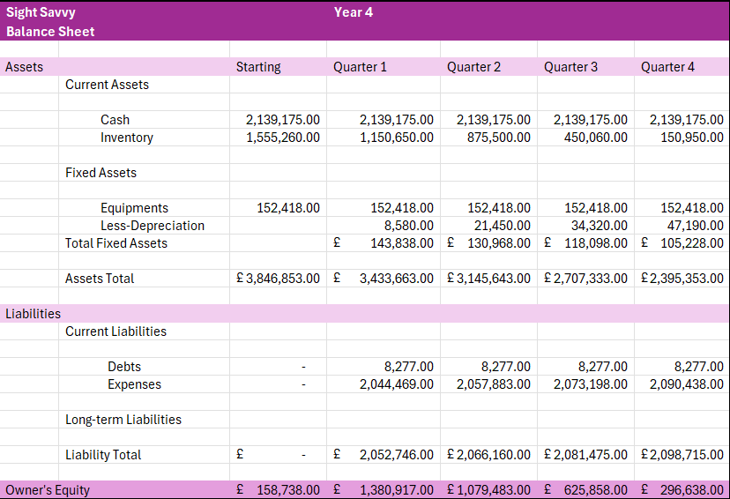

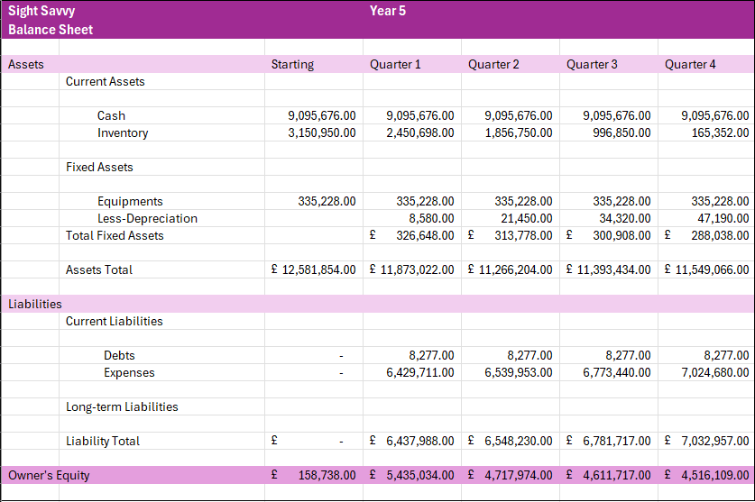

***Income Sheet***

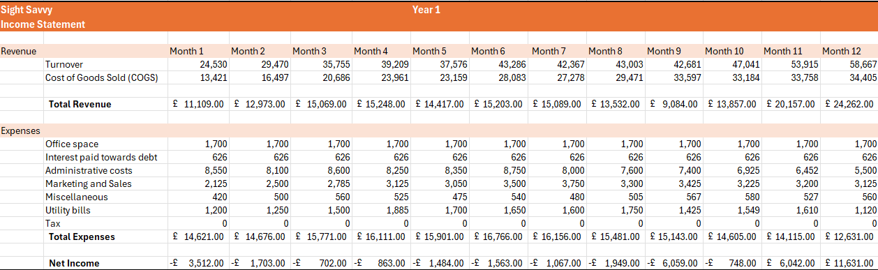

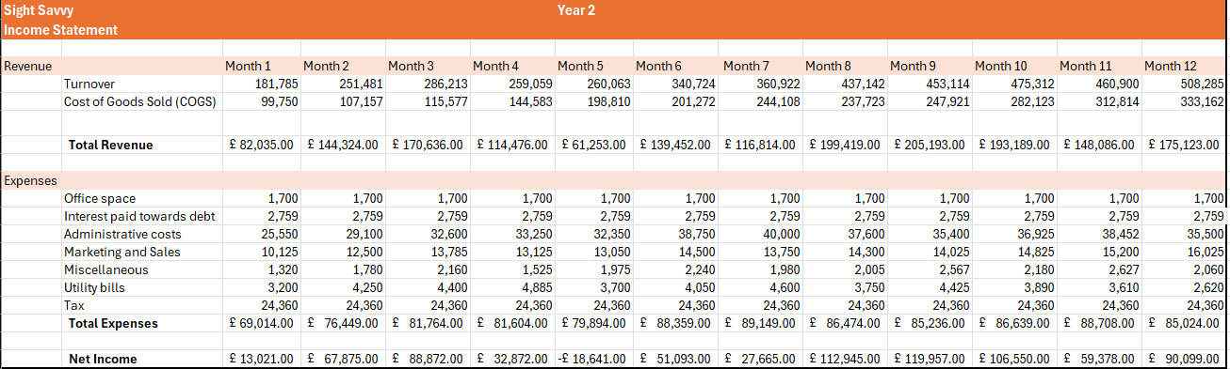

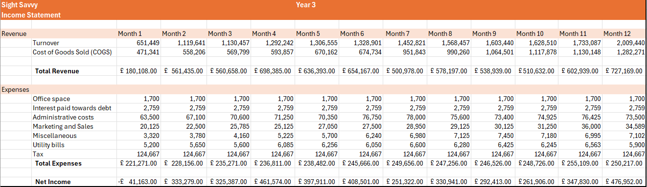

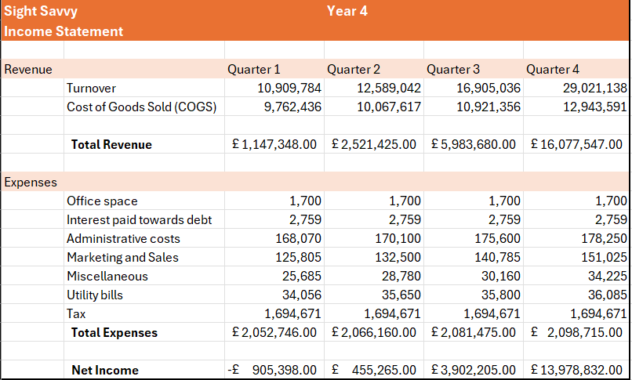

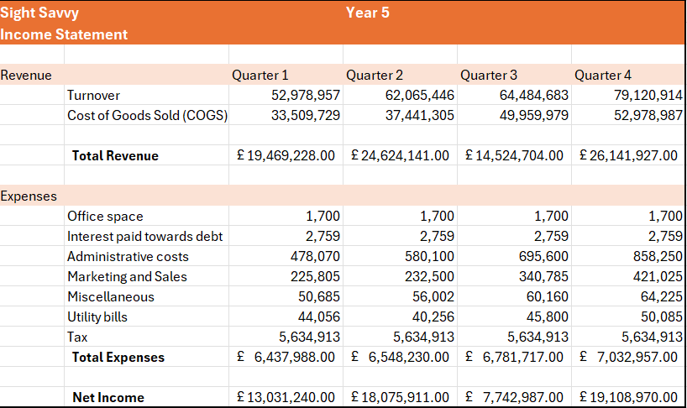

***Cash Flow***



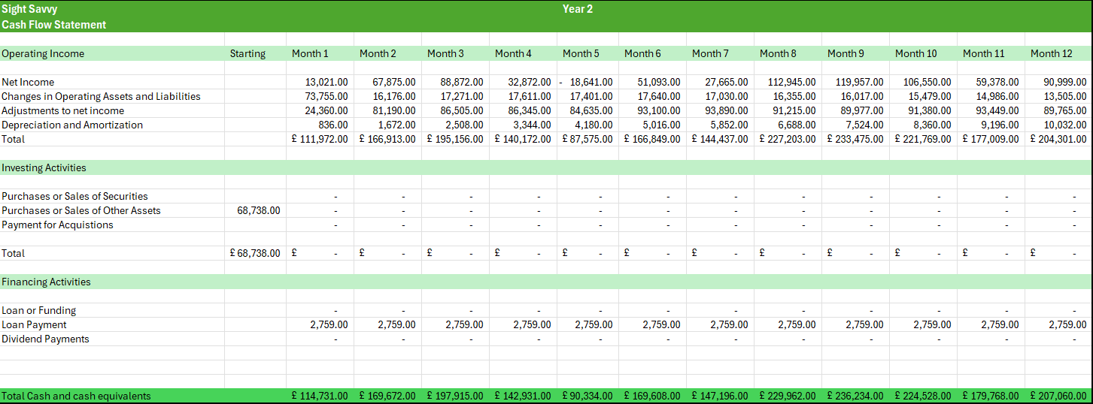



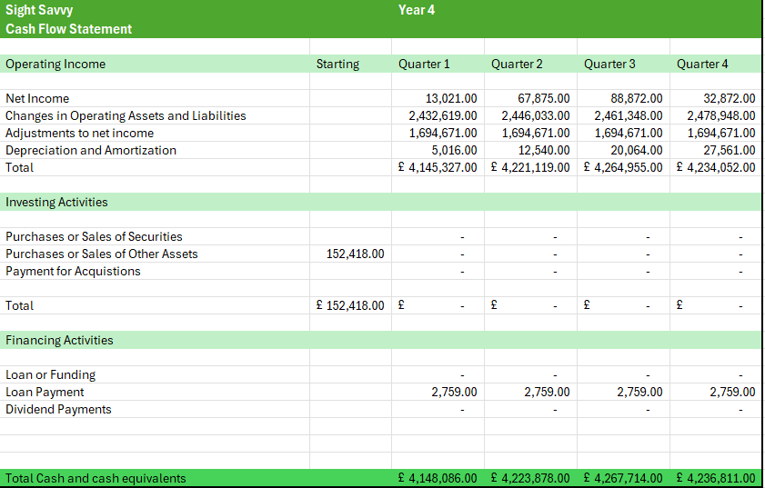

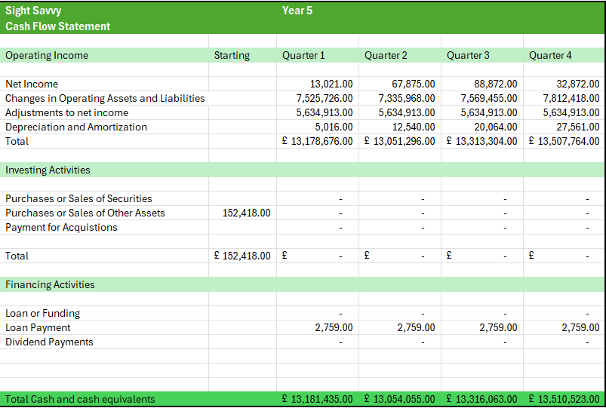

***SIGHT SAVVY WEBSITE***

